Scenario: Login with Excel based URL and Credentials
Step: And the web application URL is launched in a NewWindow - PASS
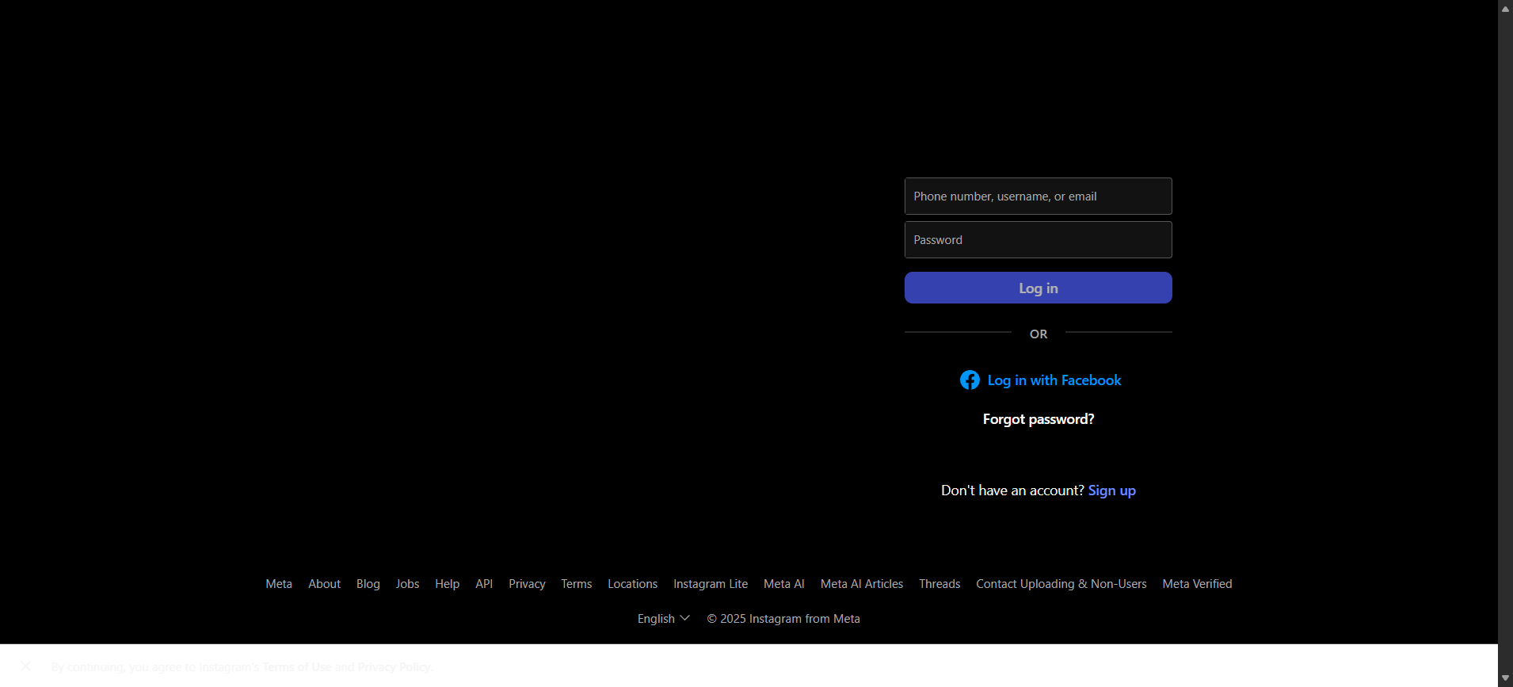
Step: And the user waits for "1" seconds - PASS

Step: Enter UserName into the "Username" textbox at "LoginPage" page - PASS

Step: Enter Password into the "Password" textbox at "LoginPage" page - PASS

Execution Summary:
Total Steps: 4
Passed: 4
Failed: 0

